Practical - 10
NAME: Soumya Dixit
PRN: 2307521151

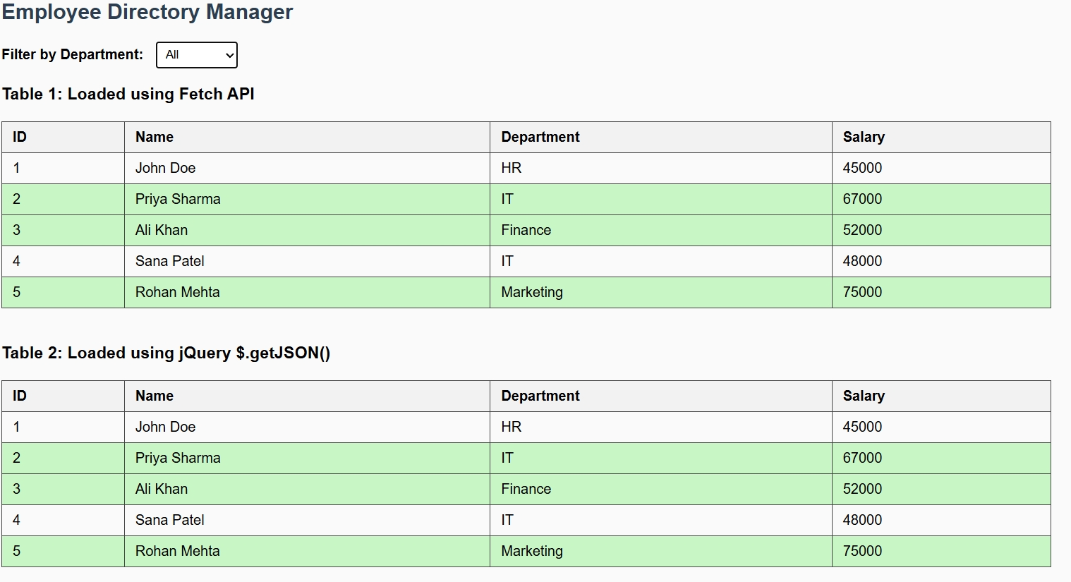
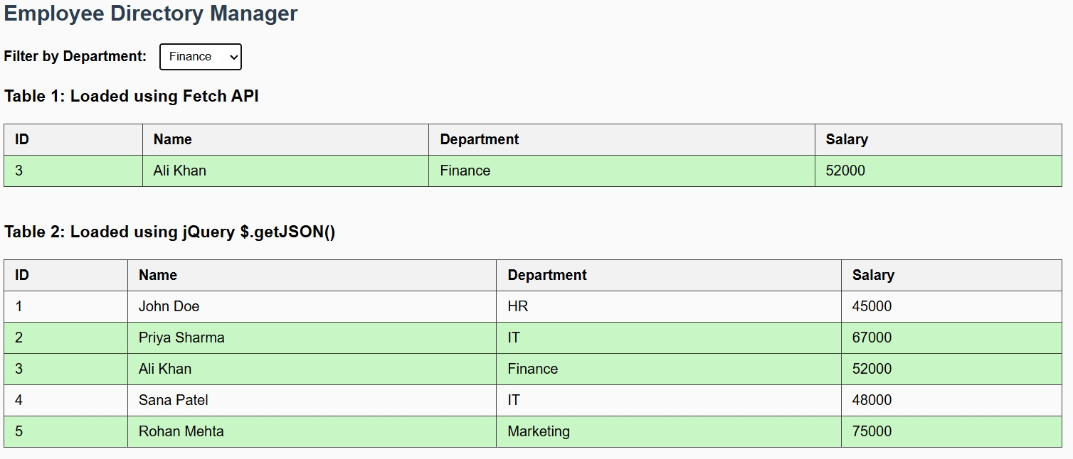
HTML:
<!DOCTYPE html>
<html lang="en">
<head>
<meta charset="UTF-8">
<title>Employee Directory Manager</title>
<script src="https://code.jquery.com/jquery-3.7.1.min.js"></script>
<style>
body { font-family: Arial, sans-serif; margin: 20px; background-color: #fafafa; }
table { border-collapse: collapse; width: 80%; margin-top: 20px; }
th, td { border: 1px solid #444; padding: 8px 12px; text-align: left; }
th { background-color: #f2f2f2; }
.highlight { background-color: #c8f7c5; } /* Task 5: Salary highlight */
select { padding: 6px; margin-left: 10px; }
h2 { color: #2c3e50; }
.section { margin-bottom: 40px; }
</style>
</head>
<body>
<h2>Employee Directory Manager</h2>

<!-- Task 3: Dynamic Department Dropdown -->
<label for="departmentSelect"><b>Filter by Department:</b></label>
<select id="departmentSelect">
<option value="all">All</option>
</select>

<div class="section">
<h3>Table 1: Loaded using Fetch API</h3>
<table id="fetchTable"></table>
</div>

<div class="section">
<h3>Table 2: Loaded using jQuery $.getJSON()</h3>
<table id="jqueryTable"></table>
</div>

<script src="final.js"></script>
</body>
</html>
JSON
[
{"id": 1, "name": "John Doe", "department": "HR", "salary": 45000},
{"id": 2, "name": "Priya Sharma", "department": "IT", "salary": 67000},
{"id": 3, "name": "Ali Khan", "department": "Finance", "salary": 52000},
{"id": 4, "name": "Sana Patel", "department": "IT", "salary": 48000},
{"id": 5, "name": "Rohan Mehta", "department": "Marketing", "salary": 75000}
]
JAVASCRIPT
let employees = [];
// Task 1: Load data using Fetch API
fetch('final.json')
.then(res => res.json())
.then(data => {
employees = data;
console.table(employees); // Debugging
displayTable(employees, "fetchTable");
generateDepartmentDropdown(employees);
});
// Task 2: Load again using $.getJSON()
$.getJSON("final.json", function(data) {
console.table(data); // Debugging
displayTable(data, "jqueryTable");
});
// Task 3: Generate department dropdown dynamically
function generateDepartmentDropdown(data) {
const uniqueDepartments = [...new Set(data.map(emp => emp.department))];
const dropdown = document.getElementById("departmentSelect");

uniqueDepartments.forEach(dept => {
const option = document.createElement("option");
option.value = dept;
option.textContent = dept;
dropdown.appendChild(option);
});
// Task 4: Filter employees when dropdown changes
dropdown.addEventListener("change", () => {
const selectedDept = dropdown.value;
const filteredData = selectedDept === "all"
? employees
: employees.filter(emp => emp.department === selectedDept);
displayTable(filteredData, "fetchTable");
});
}
// Task 4: Display data dynamically (no static HTML tables allowed)
function displayTable(data, tableId) {
const table = document.getElementById(tableId);
table.innerHTML = ""; // Clear existing table
// Create header row
const headerRow = document.createElement("tr");
["ID", "Name", "Department", "Salary"].forEach(text => {
const th = document.createElement("th");
th.textContent = text;
headerRow.appendChild(th);
});
table.appendChild(headerRow);
// Create rows
data.forEach(emp => {
const row = document.createElement("tr");
// Task 5: Highlight employees with salary > 50000
if (emp.salary > 50000) row.classList.add("highlight");
const tdId = document.createElement("td");
tdId.textContent = emp.id;
const tdName = document.createElement("td");
tdName.textContent = emp.name;
const tdDept = document.createElement("td");
tdDept.textContent = emp.department;
const tdSalary = document.createElement("td");
tdSalary.textContent = emp.salary;
row.append(tdId, tdName, tdDept, tdSalary);
table.appendChild(row);
});
}

